Chime for Slim Wireless Video Doorbell
SKU: SHA5290

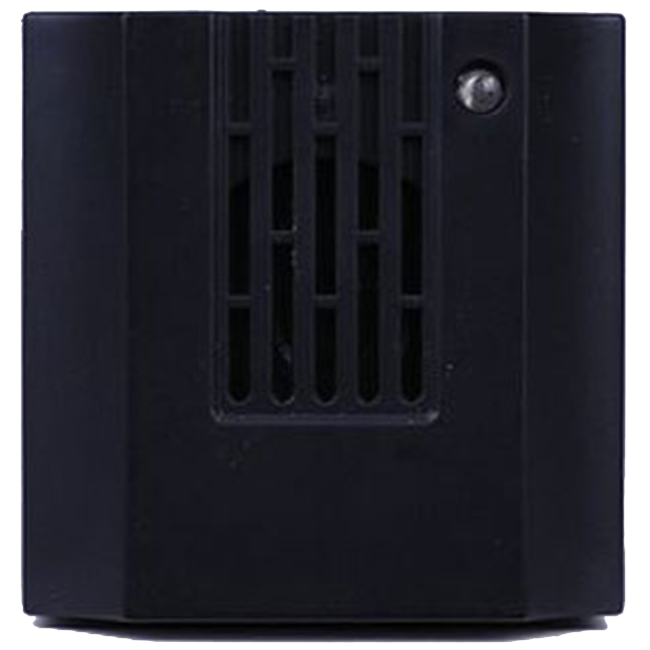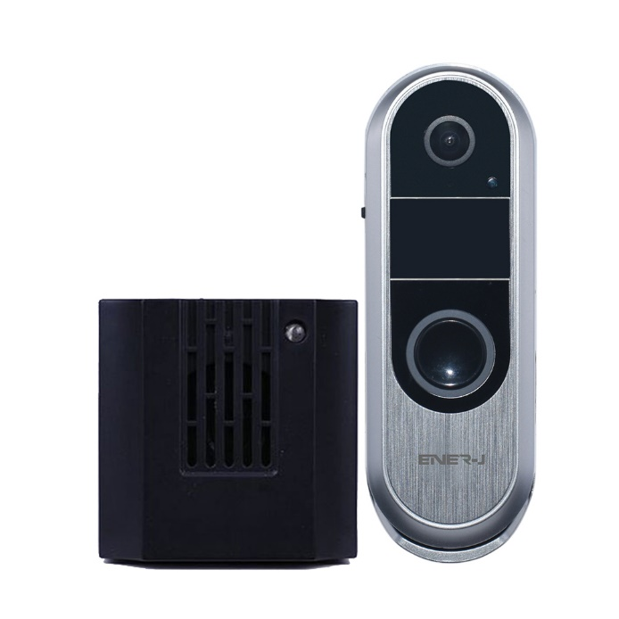

Specification:
Adjustable Ringtone:
- Ringtones: Choose from 18 melodious
- Max volume: 5 Volume levels (including mute)
- Decibels: Up to 100db
- Range: 25 meters in indoor, 200 meters in open area
- RF: 433MHz
- Power: 230W
- Plug: UK plug
- Size (without plug): 68x44x68mm
- Weight: 65g

